# LAMPIRAN

Lampiran 1 Data Fasilitas Kesehatan

| Nama | Alamat | Latitude | Longitude |
| --- | --- | --- | --- |
| Puskesmas Arjuno | Jl. Arjuno No.17 | -7.9781387 | 112.6266307 |
| Puskesmas Bareng | Jl. Bareng Tebes IV A / 639 | -7.9788353 | 112.6232203 |
| Puskesmas Celaket | Jl. Simpang Kasembon No.5 | -7.9815062 | 112.6267827 |
| Puskesmas Cisadea | Jl. Cisadea No.19 | -7.95544 | 112.643587 |
| Puskesmas Kendal Kerep | Jl. Sulfat No.100 | -7.9612031 | 112.6508529 |
| Puskesmas Pandan wangi | Jl. LA. Sucipto No.315 | -7.9472411 | 112.6552292 |
| Puskesmas Kedungkandang | Jl. Ki Ageng Gribig No.242 | -7.9931129 | 112.648131 |
| Puskemas Gribig | Jl. Ki Ageng Gribig, Malang | -7.9807003 | 112.6653153 |
| Puskemas Arjowinangun | Jl. Raya Arjowinangun no.2 | -8.038622 | 112.641816 |
| Puskesmas Janti | Jl. Janti Barat No.88 | -8.001 | 112.620549 |
| Puskesmas Cipto Mulyo | Jl. Kol. Sugiyono VIII No.54 | -8.002043 | 112.6299579 |
| Puskesmas Dinoyo | Jl. Keramik No.2 | -7.943378 | 112.611279 |
| Puskesmas Mojolangu | Jl. Sudimoro No.17A | -7.93529 | 112.626973 |
| Puskesmas Mulyorejo | Jl. Budi Utomo No.11 A | -7.982074 | 112.626938 |
| Puskesmas Kendalsari | Jl. Cengger Ayam No.8 | -7.9462596 | 112.6308858 |
| RB Pemkot | Jl. Panji Suroso No.9 | -7.9422168 | 112.6489084 |
| Optik Vista | Jl. S. Wiryo Pranoto no.31 A | -7.9849539 | 112.6311039 |
| Optik Internasional | Jl. S. Wiryo Pranoto no.25 | -7.984637 | 112.631215 |
| Optik Intercontinental | Jl. S. Wiryo Pranoto no.2F | -7.984718 | 112.6308313 |
| Optik Focus | Jl Kahuripan No 16B Malang | -7.976424 | 112.630321 |
| Optik Internasional Kepuh | Jl. S. Supriadi No. 45 A | -8.0122059 | 112.620164 |
| Optik Internasional Dinoyo | Jl. MT Haryono Nomor 167-A | -7.939103 | 112.607752 |
| Optik Internasional Blimbing | Jl. Ahmad yani No 14- B | -7.943631 | 112.641671 |
| Optik Star | Jl. Letjen Sutoyo No 56 | -7.960937 | 112.636843 |
| Optik Indo | Jl. Arif Rahman Hakim No.26F | -7.9807588 | 112.6276946 |
| RSUD Kota Malang | Jl. Rajasa- Bumiayu no.27 | -8.0263478 | 112.6393954 |
| Rumah Sakit Permata bunda | Jl. Soekarno Hatta No.75 Mojolangu | -7.938896 | 112.6248248 |
| RUMKITBAN | Jl. Panglima Sudirman | -7.9740891 | 112.6386934 |
| Rumah Sakit dr. Soepraoen | Jl. S Supriadi No 22 | -7.989928 | 112.6214189 |
| Rumah Sakit Islam Unisma | Jl. Mayjend Haryono No.139 | -7.9401441 | 112.6090101 |
| RSIA Puri Bunda | Jl. Simpang Sulfat Utara 60 A | -7.9586933 | 112.6554416 |
| RSIA Melati Husada | Jl. Kawi No 32 | -7.9760335 | 112.6213975 |
| RSI Aisyiyah | Jl. Sulawesi no 19 | -7.9886734 | 112.6252909 |
| Rumah Sakit Umum Lavelette | Jl. W.R. Supratman No. 10 | -7.965773 | 112.637877 |
| Rumah Sakit Panti Nirmala | Jl. Kebalen Wetan No. 2-8 | -7.994361 | 112.633917 |
| RSIA Muhammadiyah | Jl. Wahid Hasyim No. 30 | -7.9841278 | 112.6290835 |
| RSIA Galeri Candra | Jl Andong No. 3 | -7.947945 | 112.619574 |
| Rumah Sakit Persada Hospital | Jl. Panji Suroso ,Araya Bussines Centre Kav. II-IV | -7.9349396 | 112.6499545 |
| Rumah Sakit Panti Waluya Sawahan | Jl. Nusakambangan No. 56 | -7.9863695 | 112.6250535 |
| Rumah Sakit dr. Saiful Anwar | Jl. JA Suprapto No 2 | -7.9724887 | 112.6315624 |
| Klinik Rawat Jalan Ontoseno | Jl. Ontoseno I No. 2 | -7.983812 | 112.644408 |
| Klinik Hamid Rusdi | Jl. Hamid Rusdi No.45 | -7.967988 | 112.641404 |
| G and G Health Clinic | Jl. Terusan Kawi Kav 9 No 9 | -7.974097 | 112.616038 |
| Klinik Melati | Jl. Jaksa Agung Suprapto No 23 | -7.97103 | 112.63127 |
| Klinik 24 Jam Griya Bromo | Jl. Bromo No. 7 | -7.978175 | 112.625476 |
| Klinik Melati Panjaitan | Jl. Mayjend Panjaitan 247 Kav 1 | -7.951537 | 112.617086 |
| Klinik Kimia Farma Bromo | Jl. Bromo No 1 | -7.9788646 | 112.6250992 |
| Klinik bahrul Magfiroh | Jl. Batu Permata no 1 | -7.933713 | 112.603226 |
| Klinik Panti Rahayu | Jl. Simpang Borobudur no. 1 | -7.939823 | 112.638683 |
| Poliklinik Widya Husada | Jl. Sudimoro 16 | -7.9384024 | 112.6319623 |
| Klinik Elisa | Jl. Danau Toba E5/22 | -7.979889 | 112.658277 |
| Pr. Adi Bungsu | Jl. Ki Ageng Gribig No.1 | -7.983254 | 112.660959 |
| Klinik Telemedika Healt Center | Jl. Raya Danau Sentani Blok IV STO Telkom Sawojajar | -7.9795591 | 112.6630636 |
| Klinik Dinamika Sehat | Jl. Danau Maninjau Barat B1 A47 | -7.9747938 | 112.6557391 |
| Klinik Rawat Jalan Delta | Jl. Raya Kepuh No.47 | -8.012545 | 112.620252 |
| Klinik Bentoel Medical Center | Jl. Niaga No. 25 | -7.998205 | 112.627385 |
| Klinik Daqu Sehat | Jl. Bendungan Sigura-Gura Barat Raya 15 A | -7.957014 | 112.605837 |
| Klinik Rawat Jalan Rampal (TNI AD) | Jl. Panglima Sudirman No D-9A | -7.9724717 | 112.6385239 |
| Poliklinik POLRES Malang Kota | Jl. Pahlawan Trip No. 1 | -7.9687009 | 112.6226655 |
| Balai Kesehatan LANAL Malang (TNI-AL) | Jl. Yos Sudarso No.14 | -7.9913836 | 112.6252941 |
| Klinik Wira Husada (TNI-AD) | Jl. Sudanco Supriadi No.23 | -7.974165 | 112.6641197 |
| Instalasi Farmasi RSSA | Jl. Jaksa Agung Suprapto No 2 | -7.9724887 | 112.6315624 |
| IFRS Dr. Soepraoen | JL. S. Supriyadi, No. 22 | -7.9899277 | 112.6214186 |
| IFRS Melati Husada | Jl. Kawi No.32 | -7.9760335 | 112.6213975 |
| IFRSI Aisyiyah | Jl. Sulawesi No.16 | -7.9886734 | 112.62529090 |
| IFRS Lavalette | Gg. III No.10, Rampal Celaket | -7.965773 | 112.637877 |
| IFRS Permata Bunda | Jl. Soekarno Hatta No.75 | -7.938896 | 112.6248248 |
| IFRS Puri Bunda | Jl. Simpang Sulfat Utara No. 60 A | -7.9586933 | 112.6554416 |
| IFRS. Islam Unisma | Jl. M.T. Haryono | -7.9401441 | 112.6090101 |
| IFRS. Ganesha Medika | Jl. Mayjend. Panjaitan | -7.9529006 | 112.6191426 |
| IFRS Panti Nirmala | Jl. Kebalen Wetan 2-8, Kotalama | -7.994361 | 112.633917 |
| IFRS Muhammadiyah Tongan | Jl. Wahid Hasyim No. 30 | -7.9845635 | 112.628742 |
| IFRS Rumkitban Kota Malang | Jl. Panglima Sudirman | -7.9740891 | 112.6386934 |
| IFRSIA Galeri Candra | Jl. Bunga Andong No.3 | -7.947945 | 112.619574 |
| IFRS PERSADA HOSPITAL | Kompleks Araya Business Centre Kav. 2-4, Jalan Pan | -7.9349396 | 112.6499545 |
| IFRS PANTI WALUYA SAWAHAN | Jl. Nusakambangan No.56 | -7.9863695 | 112.6250535 |

Lampiran 2 Form Verifikasi Abstrak dan Tata Tulis

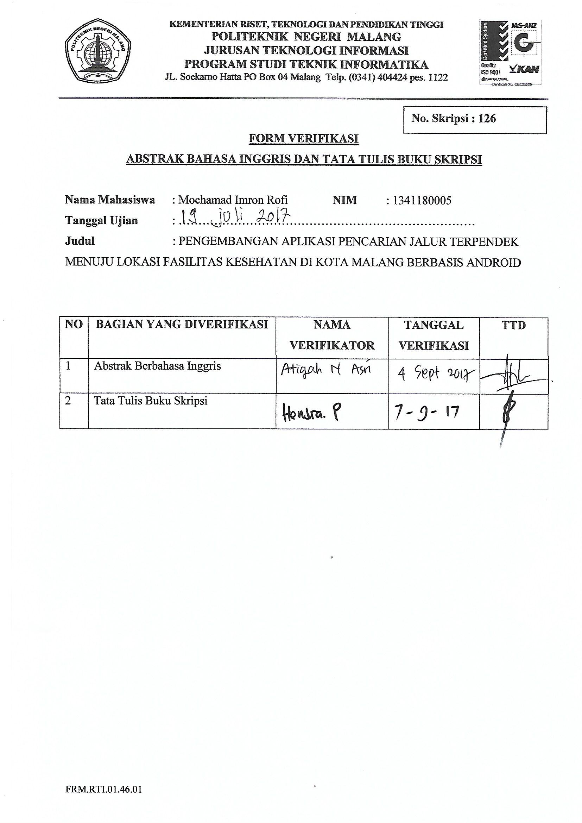

Lampiran 3 Lembar Persetujuan

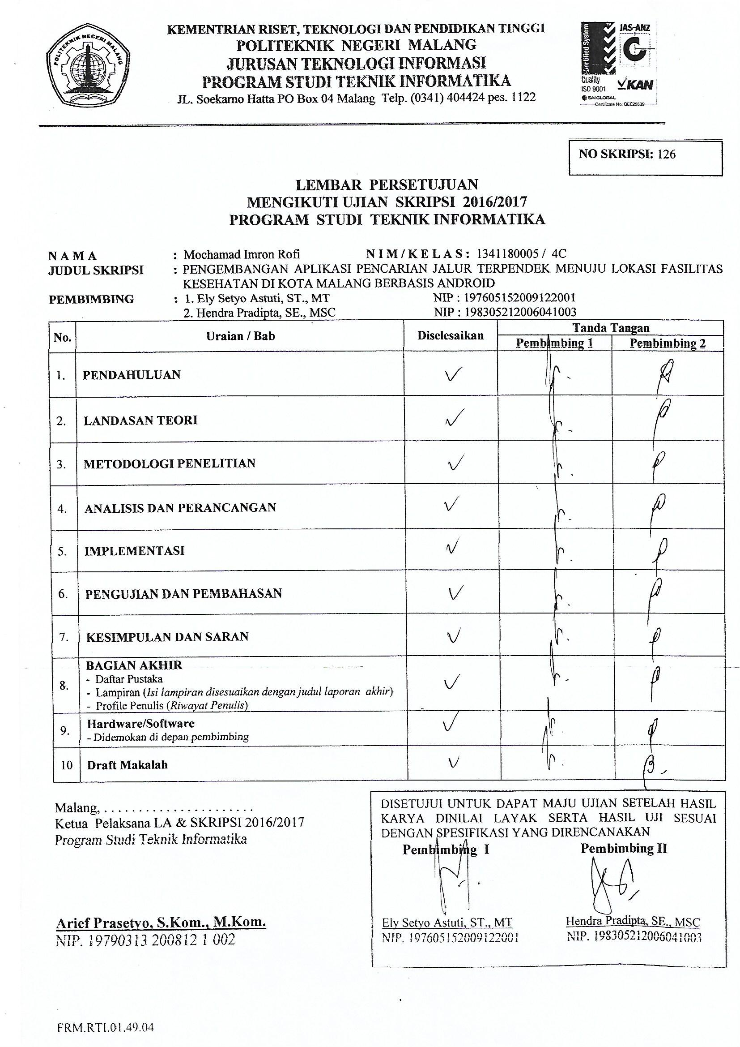

Lampiran 4 Lembar Bimbingan Bu Ely

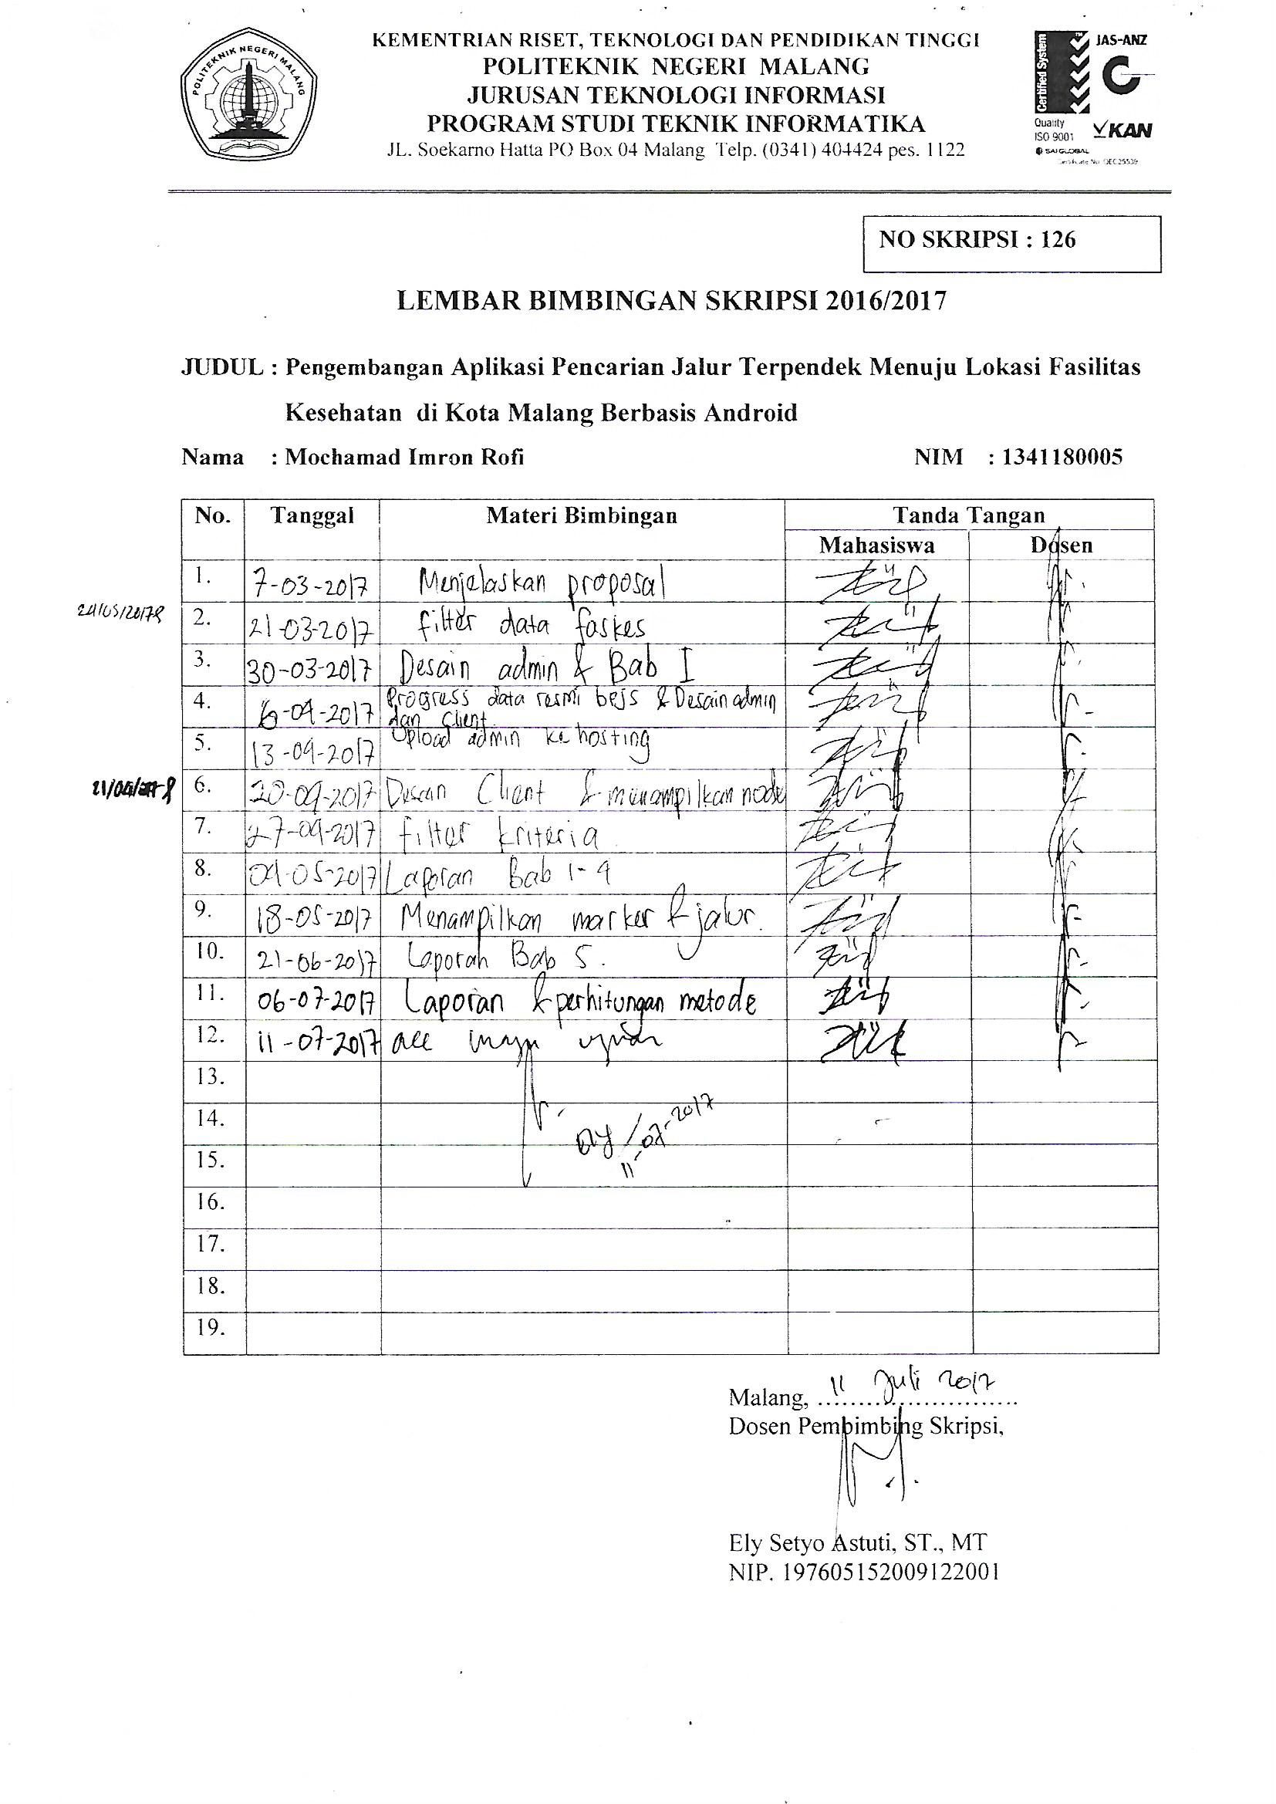

Lampiran 5 Lembar Bimbingan Pak Hendra

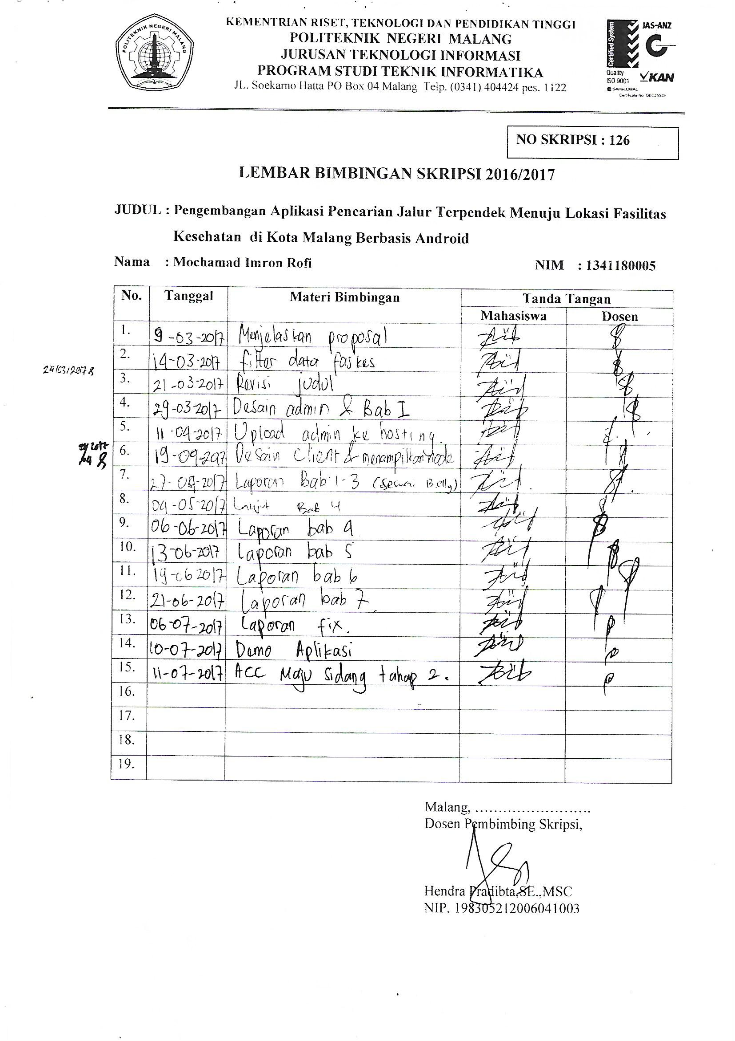

Lampiran 6 Lembar Revisi Pak Yuri

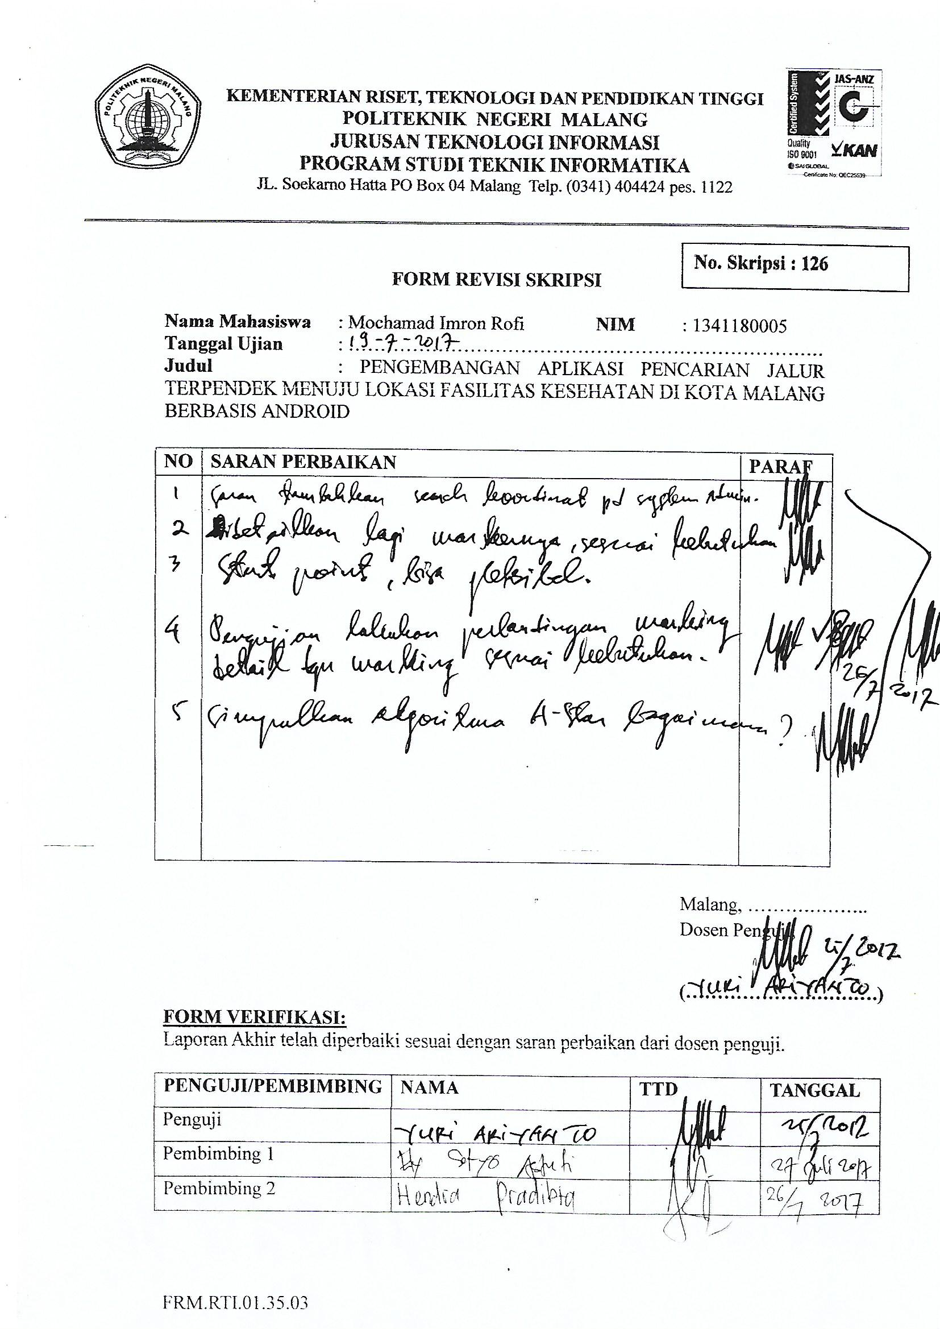

Lampiran 7 Lembar Revisi Pak Ridwan

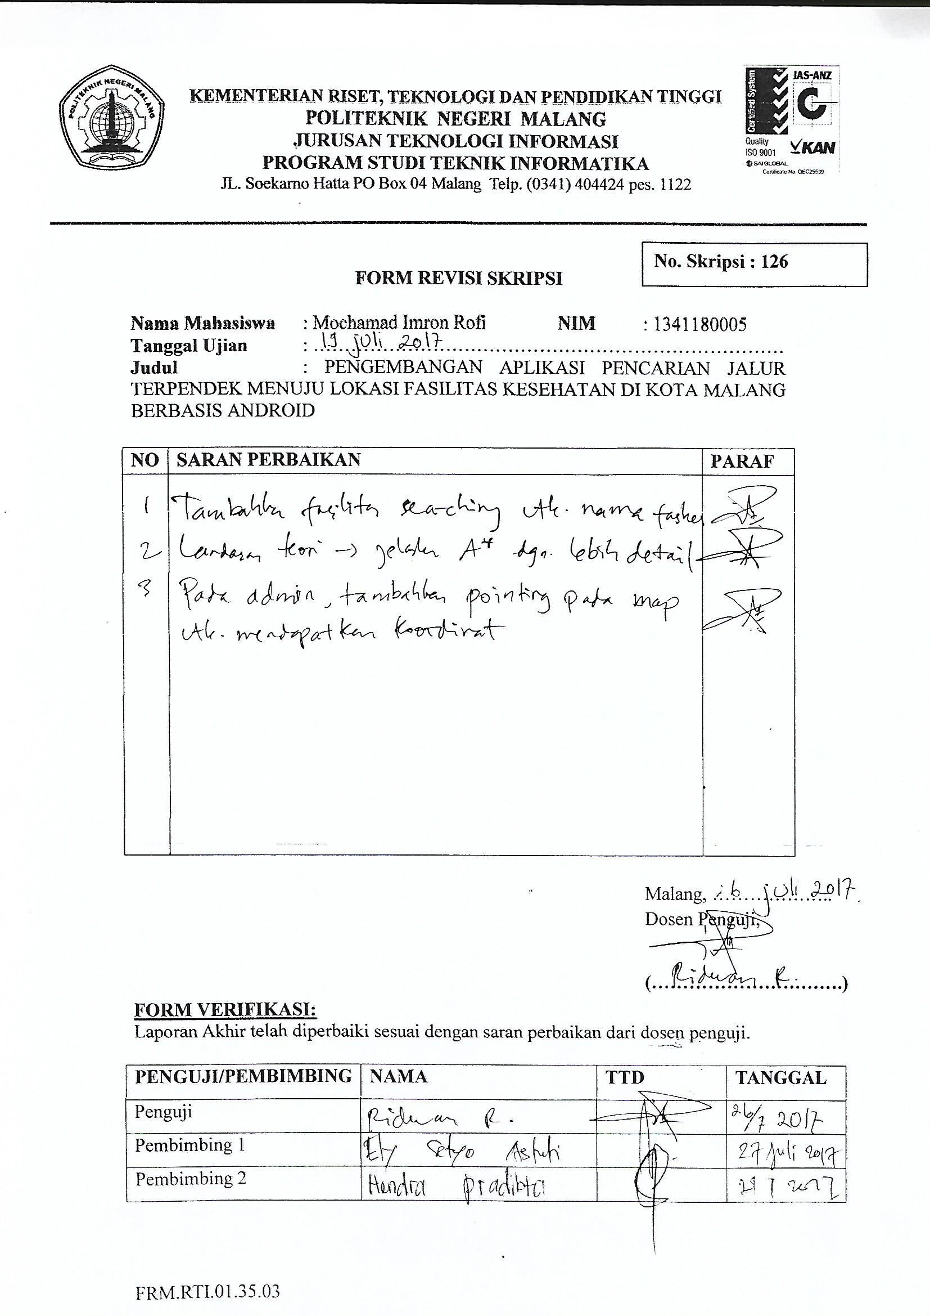

Lampiran 8 Kuesioner

